IT Earthing System
- Search on the internet how a TT Earthing System looks like. Place a picture of this Earthing System here below.
- Wich of the Earthing System Board would you need to create this system. Place Them in the correct order en draw the connections on it.

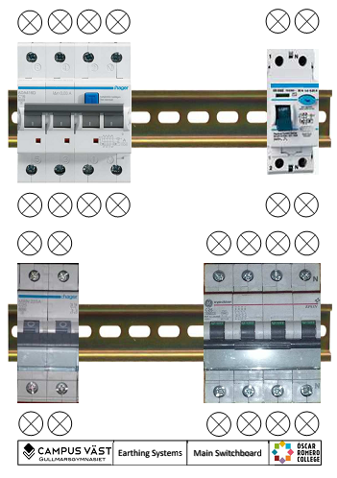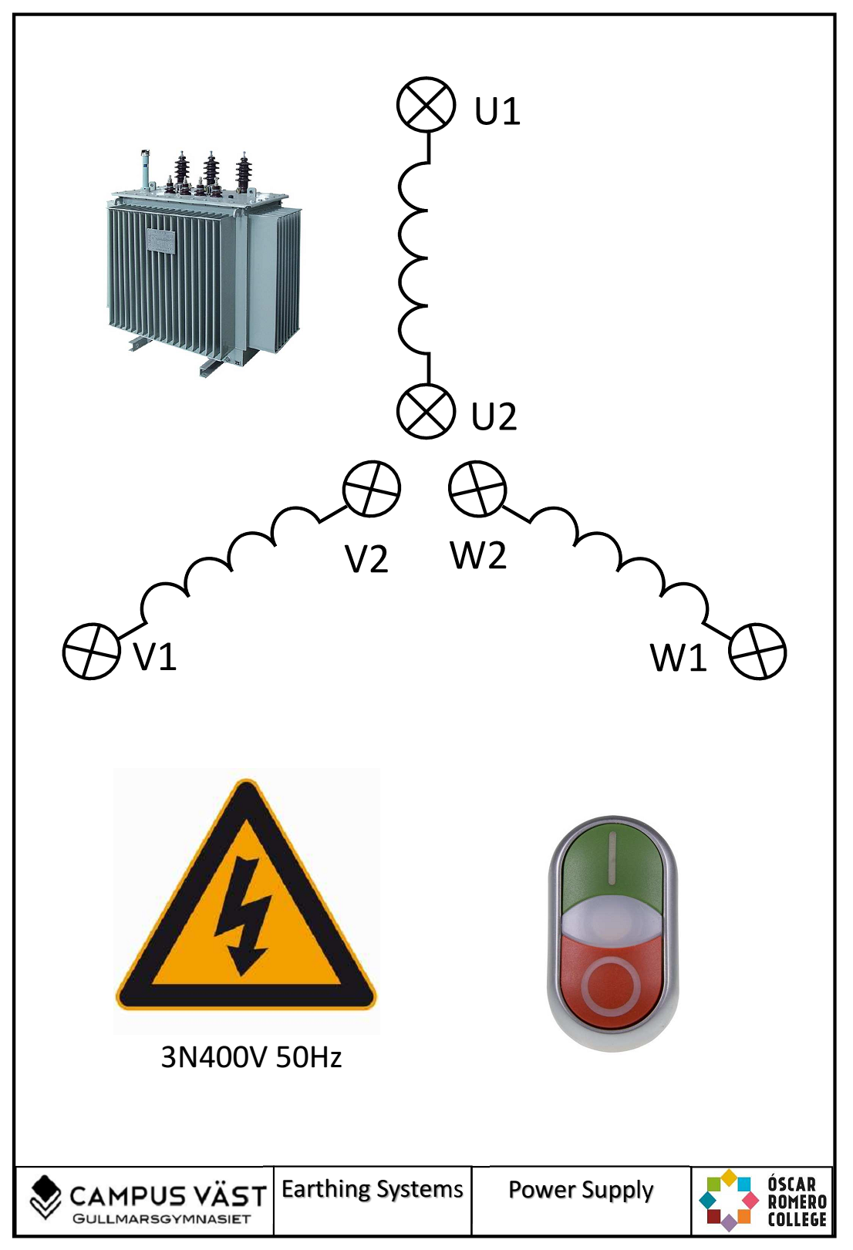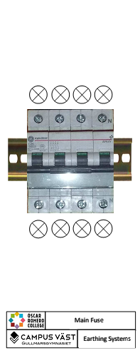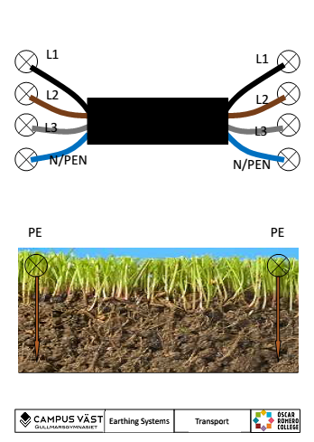

- Where is this system used?

- Build the system and do some measurements.
Messure points |  | Voltage (V)
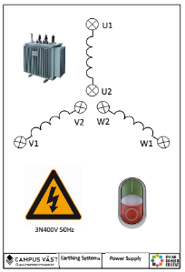  Messure on this board. | U1+W1
 | U1+V1
 | W1+V1
 | U1+PE (U2, W2, V2)

Messure points |  | Voltage (V)
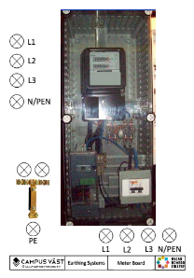  Messure on this board. | L1+L2
 | L1+L3
 | L2+L3
 | L1+N

- In a real life system what would the values be?
Messure points |  | Voltage (V)
On this board. | U1+W1
 | U1+V1
 | W1+V1
 | U1+N (U2, W2, V2)

- Ad this board to the system and connect it to the 4-fase circuit breaker. Don’t use the earth leakage circuit breaker.

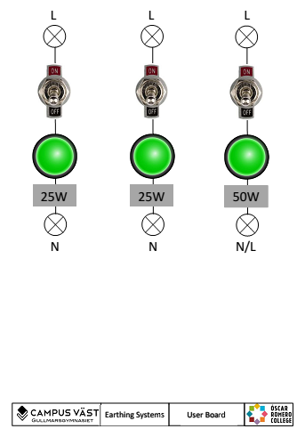

and make the following connections.
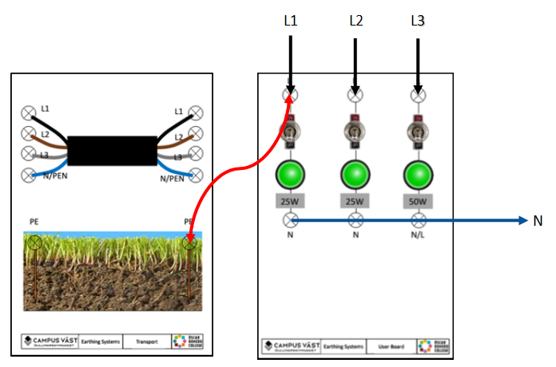
What happens? Why does this happen?

Now add another connection.
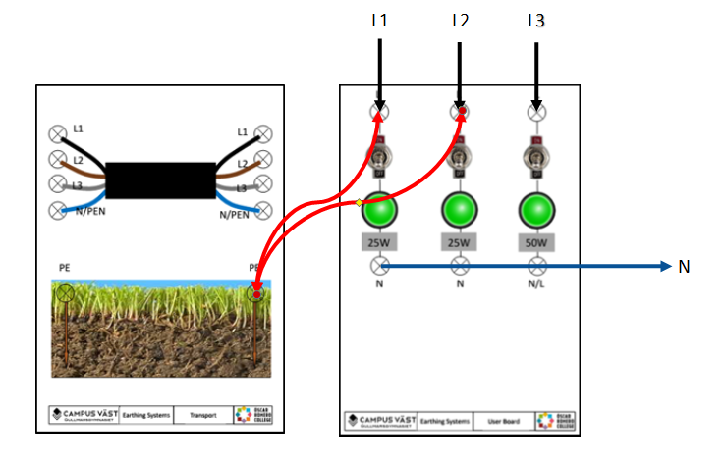
What happens? Why does this happen? Which actions should be taken?

