TN-C-S Earthing System
- Search on the internet how a TN-C-S Earthing System looks like. Place a picture of this Earthing System here below.
- Wich of the Earthing System Board would you need to create this system. Place Them in the correct order en draw the connections on it.

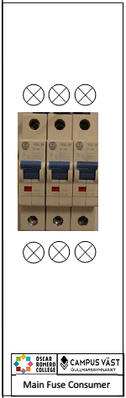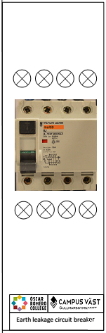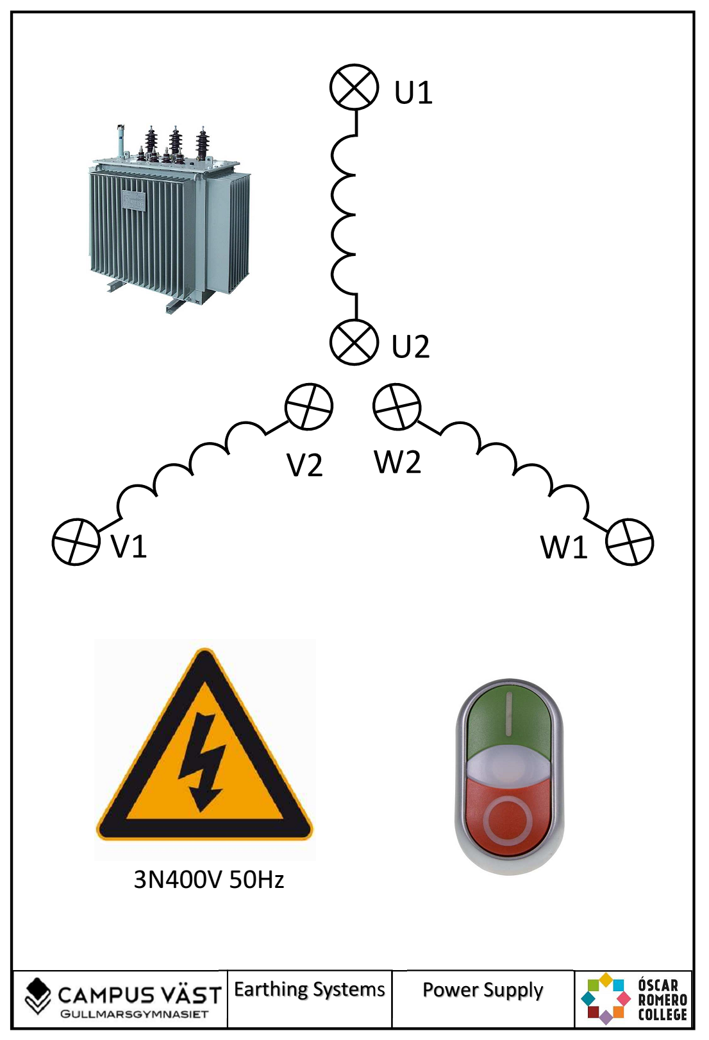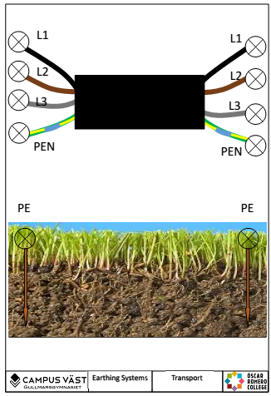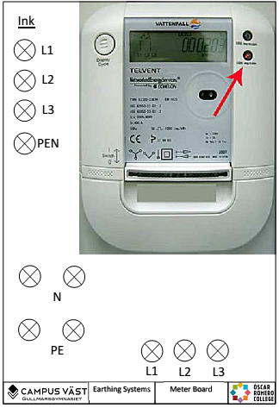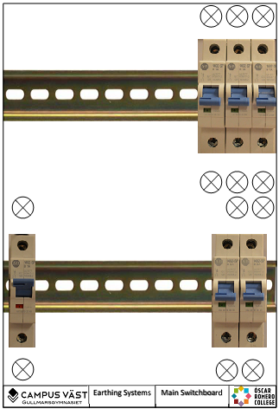

- Where is this system used?

- Build the system and do some measurements.
Messure points |  | Voltage (V)
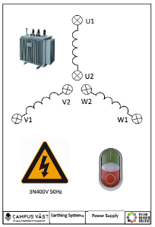  Messure on this board. | U1+W1
 | U1+V1
 | W1+V1
 | U1+PEN (U2, W2, V2)

Messure points |  | Voltage (V)
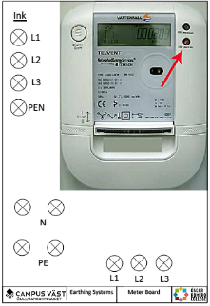  Messure on this board. | L1+L2
 | L1+L3
 | L2+L3
 | L1+PEN

- In a real life system what would the values be?
Messure points |  | Voltage (V)
On this board. | U1+W1
 | U1+V1
 | W1+V1
 | U1+PEN (U2, W2, V2)

- Ad this board to the system and connect it to the 1-fase circuit breaker. 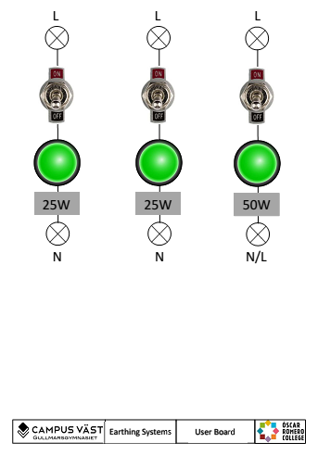

and make the following connections.
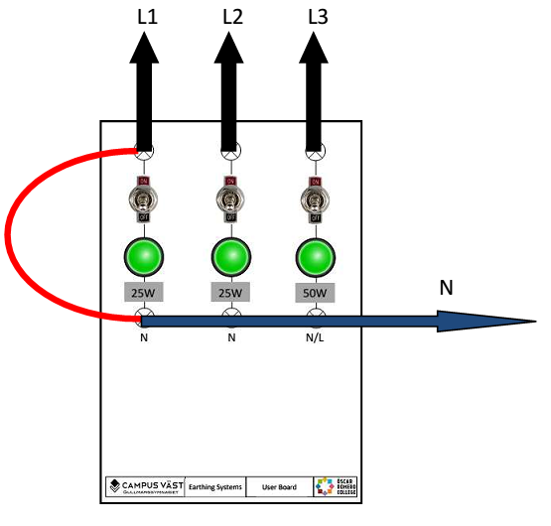
What happens? How do you call this phenomenon?
- Make the following connections.
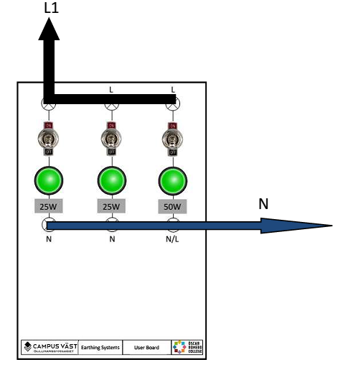
Turn on the switches one by one and measure the voltage on the lamps
Voltage over lamp 1 (25W) .........................................................
Voltage over lamp 1 (25W) .........................................................
Voltage over lamp 1 (50W) .........................................................
What happens after you turn on all switches? How do you call this phenomenon? Remark: be patient it could take a few minutes before something happens.
Search for a circuit breaker characteristic and show what is happening.

- Ad this board to the system and connect it to the 2-pole circuit breaker.

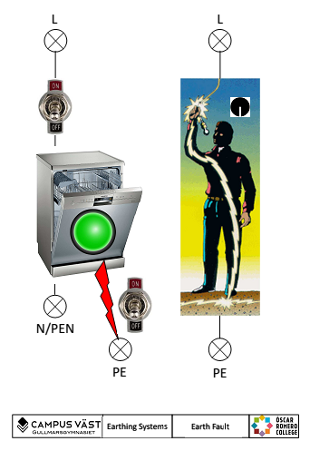

- Make the following connections.
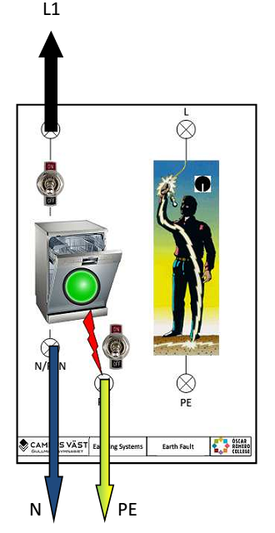
Turn on both switches. What happens? How do you call this phenomenon?
- Make the following connections.
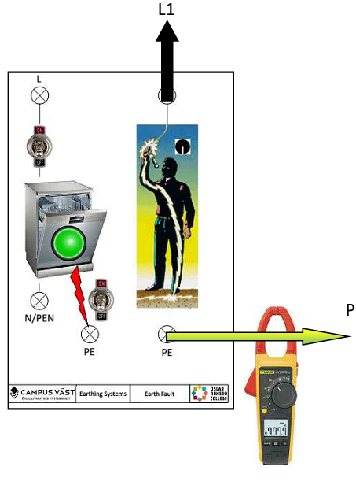

Messure the current at the different positions of the switch. Write down the value.
Switch position 1: ......................................................
Switch position 2: .......................................................
Switch position 3: .......................................................
Switch position 4: .......................................................

What happens? How do you call this type of current?

