TT Earthing System
- Search on the internet how a TT Earthing System looks like. Place a picture of this Earthing System here below.
- Wich of the Earthing System Board would you need to create this system. Place Them in the correct order en draw the connections on it.

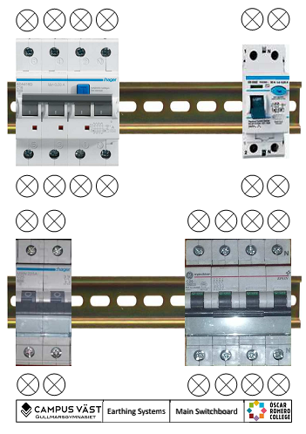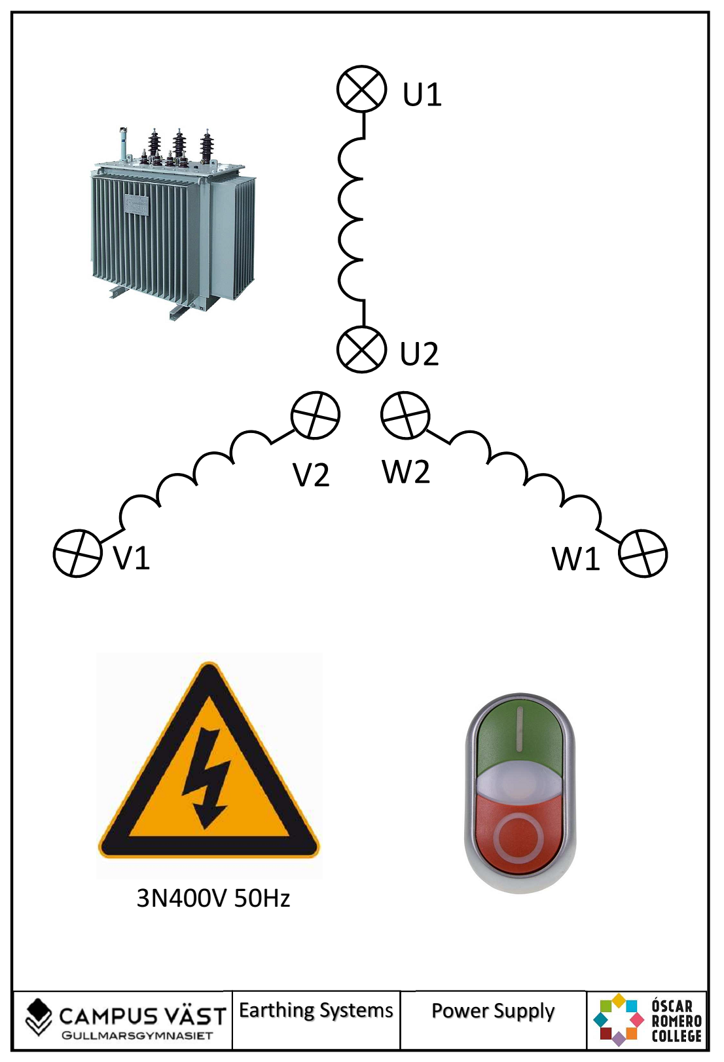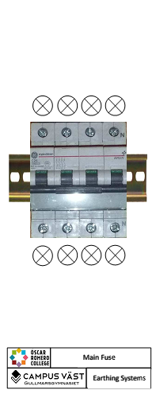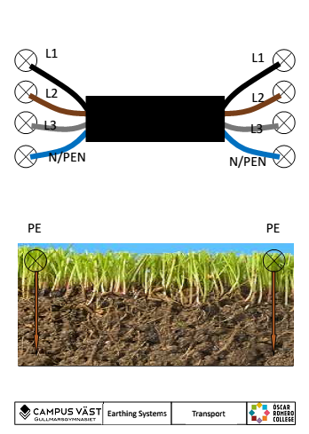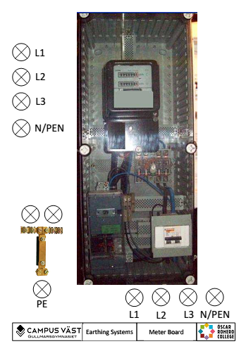

- Where is this system used?

- Build the system and do some measurements.
Messure points |  | Voltage (V)
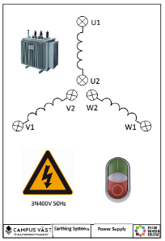  Messure on this board. | U1+W1
 | U1+V1
 | W1+V1
 | U1+Zero (U2, W2, V2)

Messure points |  | Voltage (V)
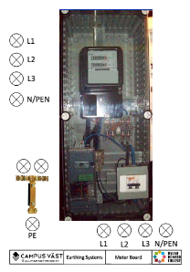  Messure on this board. | L1+L2
 | L1+L3
 | L2+L3
 | L1+PEN

- In a real life system what would the values be?
Messure points |  | Voltage (V)
On this board. | U1+W1
 | U1+V1
 | W1+V1
 | U1+Zero (U2, W2, V2)

- Ad this board to the system
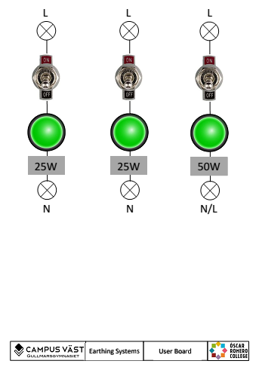

and make the following connections.
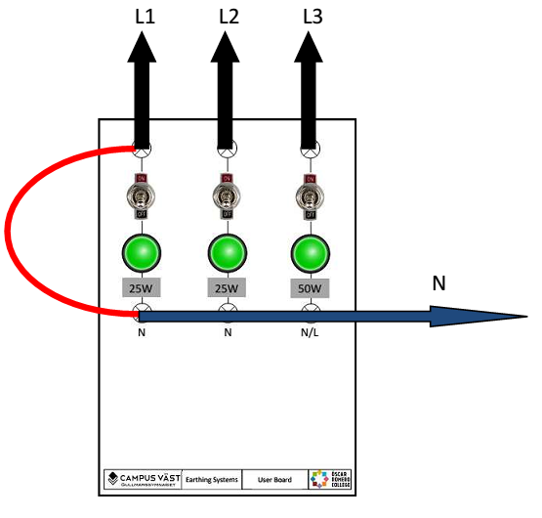
What happens? How do you call this phenomenon?
- Make the following connections.
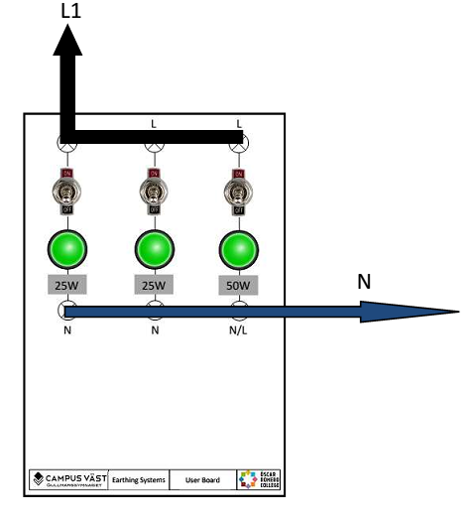
What happens when you turn on all switches? How do you call this phenomenon? Remark: be patient it could take a few minutes before something happens.

- Ad this board to the system

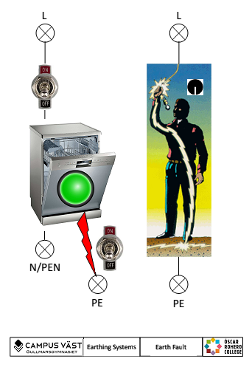

- Make the following connections.

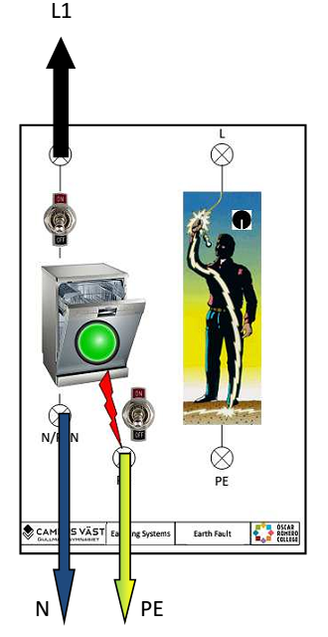
Turn on both switches. What happens? How do you call this phenomenon?

Open up the earth connector switch (on the board below) and turn on both switches? What happens?

- Make the following connections.
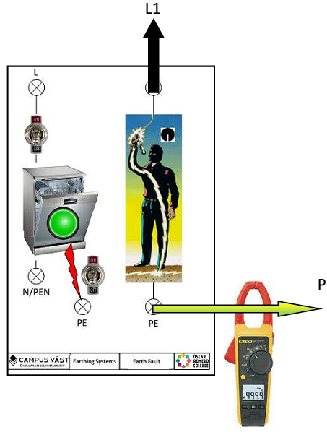

Messure the current at the different positions of the switch. Write down the value.
Switch position 1: ......................................................
Switch position 2: .......................................................
Switch position 3: .......................................................
Switch position 4: .......................................................

What happens? How do you call this type of current?
- Make the following connections.

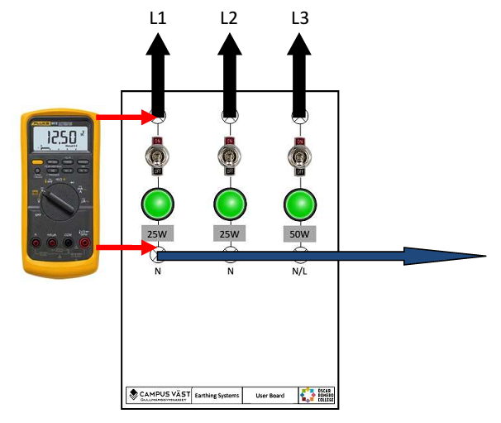

Measure the different voltages on the lamps.
Voltage over lamp 1 (25W) .........................................................
Voltage over lamp 2 (25W) .........................................................

Interrupt or disconnect the neutral on the board bellow and measure the different voltages on the lamps.
Voltage over lamp 1 (25W) .........................................................
Voltage over lamp 1 (25W) .........................................................
Voltage over lamp 1 (50W) .........................................................

What happens?
Can you find an explanation for this?

